No Photo Available

Atchisson / Dae Woo Assault 12
Ammo | Mag | Rng | ROF | Dam | Arm
12 Gauge | 20 / 7 | 45 | 4 | 4 | x4
Description: A devastating close-in weapon, the Assault 12 was designed by the US and manufactured in South Korea. It is surprisingly light, and uses a 20 round drum or 7 round magazine. The weapon was popular with arms collectors, but never saw large-scale military services because of competition from better-marketed designs.
Nation: South Korea and United States Weight: 3.5 kg
Ammunition: 12 gauge Magazine: 20 / 7
Price: $1700 Availability: ( R/- )

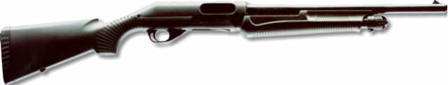
Benelli Pump Shotgun
Ammo | Mag | Rng | ROF | Dam | Arm
12 Gauge | 5 / 8 | 40 | 4 | 4 | x4
Description: Very well made, the Benelli pump shotgun is weather proof and used by “dedicated hunters,” (one’s that hunt in the bad weather). It is also very light.
Nation: Italy and United States Weight: 2.75 kg
Ammunition: 12 Gauge Magazine: 5 / 8
Price: $1000 Availability: ( S/- )

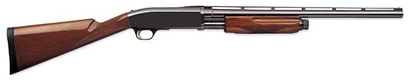
Browning BPS
Ammo | Mag | Rng | ROF | Dam | Arm
12 G | 4 / 8 | 40 | 4 | 4 | x4
Description: A standard hunting pump shotgun.
Nation: United States Weight: 3.25 kg
Ammunition: 12 Gauge Magazine: 4 / 8
Price: $500 Availability: ( V/C )

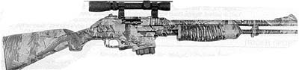
Browning Crossfire
Ammo | Mag | Rng | ROF | Dam | Arm
12 Gauge  5.56 N | 4  5 | 40  40 | 4  4 | 4  2 | x4  -
Description: The Crossfire is an excellent hunting weapon. It has two barrels. One fires 12 gauge rounds (tube loaded) and the other fires 5.56 N (.223) (magazine loaded). Both can be loaded at the same time, but not fired at the same time, as it is controlled by a selector switch. Because of the use of a common round the Crossfire is a greatly desired weapon.
Nation: United States Weight: 3.75 kg
Ammunition: 12G +5.56 N Magazine: 4+5
Price: $1200 Availability: ( S/S )
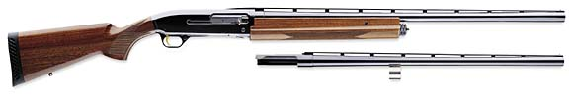
Browning Gold 10-Gauge
Ammo | Mag | Rng | ROF | Dam | Arm
10 Gauge | 3 | 45 | 2 | 5 | x4
Description: The Browning Gold is a semi-auto hunting shotgun. The 10 Gauge round, though not ease to find delivers a powerful hit.
Nation: United States Weight: 3.8 kg
Ammunition: 10 Gauge Magazine: 3
Price: $900 Availability: ( S/R )

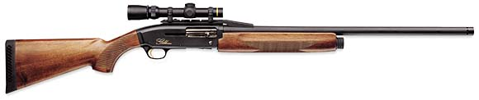
Browning Gold
Ammo | Mag | Rng | ROF | Dam | Arm
12 G | 5 | 45 | 4 | 4 | x4
Description: The 12 gauge version of the Browning Gold. Very popular precision hunting weapon.
Nation: United States Weight: 3.5 kg
Ammunition: 12 Gauge Magazine: 5 / 8
Price: $800 Availability: ( S/R )

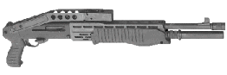
Franchi SPAS-12
Ammo | Mag | Rng | ROF | Dam | Arm
12 Gauge | 8 | 35 / 40 | 4 / 8 | 4 | x4
Description: The Sporting Purpose Automatic Shotgun, or SPAS for short was not initially designed for “sport,” but for the military. The military version is has semi, pump, and full auto settings. The civilian model has only semi and pump. With a folding stock and buttplate, it can be fired one-handed. It was built in Italy and America, and was issued to US Army MPs in Europe and the Persian Gulf personnel.
Nation: United States and Italy Weight: 4.3 kg
Ammunition: 12 gauge Magazine: 8
Price: $800 / $1500 Availability: ( S/R )

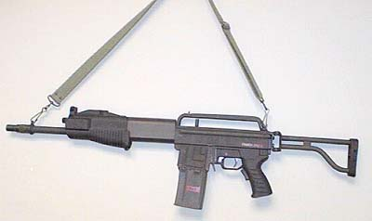
Franchi SPAS 15
Ammo | Mag | Rng | ROF | Dam | Arm
12 Gauge | 10 / 20 | 40 | 4 / 6 | 4 | x4
Description: The SPAS 15 is a more combat oriented weapon then the SPAS 12. It was designed after the M16 frame style yet still comes with a folding stock. Due to the out break of the war, the SPAS 15 was not incorporated into most militaries. The SPAS 12 is still used by most units.
Nation: United States and Italy Weight: 4.5 kg
Ammunition: 12 gauge Magazine: 20 / 30
Price: $1500 Availability: ( R/- )

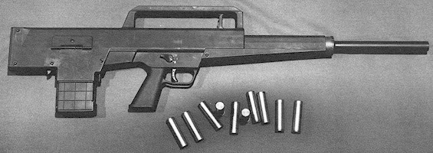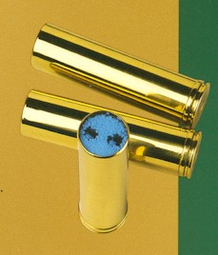
HK CAWS
Ammo | Mag | Rng | ROF | Dam | Arm
12 Gauge | 10 | 45 | 4 / 10 | 4 | x4
Description: This became the standard US and German shotgun for a short period of time before the war began. The HK CAWS (Close Assault Weapon System) is a bullpup configuration weapon and looks a little like the G11. The CAWS uses a special ammunition that was designed by Olin, with a brass casing. It has a better range than normal shotgun rounds. This ammunition may NOT be used in other shotguns without modifying the weapon (AVG task). Due to ammunition restrictions the HK CAWS was soon replaced by many individual units. It is HIGHLY advisable that characters KEEP their brass casings for this ammunition to make reloads, as normal plastic cased 12 gauge ammunition will not work effectively in this weapon. Referees may allow it but increase the chance of weapon failure. Plastic heats up quickly!!
Nation: Germany and United States Weight: 4 kg
Ammunition: 12 gauge Magazine: 10
Price: $2500 Availability: ( S/- )
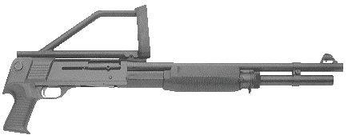
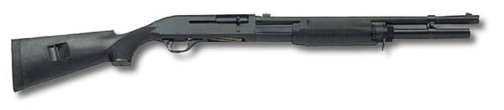
HK M3 Super Shotgun
Ammo | Mag | Rng | ROF | Dam | Arm
12 G | 7 | 40 / 45 | 4 | 4 | X4
Description: The HK and Benelli M3 has become the choice of SWAT Teams and Special Forces units around the globe. It is accurate dependable. Light weight and easy to maneuver. Even when the folding stock is not extended the M3 has a RNG of 40 (45 with stock).
Nation: United States and Germany Weight: 3.45 kg
Ammunition: 12 Gauge Magazine: 7
Price: $1,100 Availability: ( C/S )

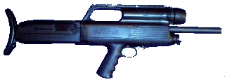
High Standard M-10
Ammo | Mag | Rng | ROF | Dam | Arm
12 Gauge | 7 | 40 | 4 | 4 | x4
Description: A bullpup configuration, gas operated, semiautomatic shotgun manufactured in the United States. Features include a folding handle with removable flashlight, folding sights, a cocking level on both sides, a pistol grip, and a yoke for firing one-handed. Intended for military and law-enforcement use, it was never manufactured in large numbers and was a collector’s item by the 1970s.
Nation: United States Weight: 3.9 kg
Ammunition: 12 gauge Magazine: 7
Price: $1250 Availability: ( R/- )

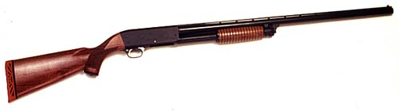
Ithaca Model 37
Ammo | Mag | Rng | ROF | Dam | Arm
12 Gauge | 8 | 40 | 4 | 4 | x4
Description: An American classic pump shotgun. It had been in use by military, police and civilians for almost 60 (1937) years before the war started. A model know as the “Deerslayer” (RNG: 45) was the first shotgun to have a fully rifled barrel (1988).
Nation: United States Weight: 3 kg
Ammunition: 12 gauge Magazine: 8
Price: $695 Availability: ( C/S )

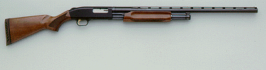
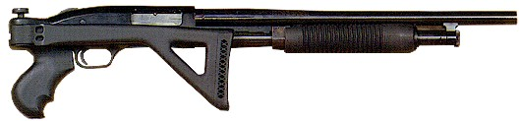
Mossberg Model 500
Ammo | Mag | Rng | ROF | Dam | Arm
12 Gauge
Description: An American made pump shotgun. Popular for home defense. It is inexpensive and good quality. The Mossberg is often called the Chevrolet of shotguns because it can be modified so easily in so many different ways. There is an accessory for everything.
Nation: United States Weight: 3.15 kg
Ammunition: 12 gauge Magazine: 8
Price: $350 Availability: ( V/R )
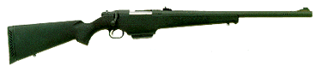
Mossberg Model 695
Ammo | Mag | Rng | ROF | Dam | Arm
12 Gauge | 5 | 50 | 2 | 4 | x4
Description: A bolt-action shotgun, the 695 was made for hitting targets from far away. The 695 has kept hunters happy for many years. It is more accurate that other shotguns and many assault rifles.
Nation: United States Weight: 3.75 kg
Ammunition: 12 Gauge Magazine: 5
Price: $1000 Availability: ( S/R )

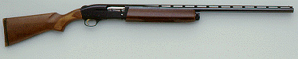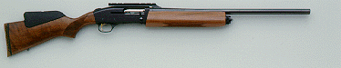
Mossberg 9200
Ammo | Mag | Rng | ROF | Dam | Arm
12 Gauge | 8 / 5 | 40 | 4 | 4 | x4
Description: The 9200 is a semi-auto shotgun used by civilians as a hunting weapon.
Nation: United States Weight: 3.75 kg
Ammunition: 12 Gauge Magazine: 5 / 8
Price: $900 Availability: ( S/R )

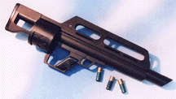
Pancor Jackhammer
Ammo | Mag | Rng | ROF | Dam | Arm
12 Gauge | 10 / 20 | 40 | 10 | 4 | x4
Description: The Jackhammer is a full auto shotgun in a bullpup configuration. Too new to be introduced fully into the armed forces, only a few of these made their way into military hands. Some US units (very few) were able to replace their HK CAWS (which use specific ammunition) for the Jackhammer (which can use regular 12 gauge rounds.
Nation: United States Weight: 4 kg
Ammunition: 12 gauge Magazine: 10 / 20
Price: $2500 Availability: ( -/- )

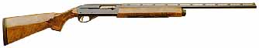
Remington Model 1100
Ammo | Mag | Rng | ROF | Dam | Arm
12 Gauge | 7 | 40 | 5 | 4 | x4
Description: An auto-loading shotgun, the 1100 was originally designed for hunting and trap shooting. The recoil spring is located in the stock of the weapon. The 1100 can be found among civilians and (being that it is such a fine weapon) military personnel have picked some up here and there. It is always nice to have a shotgun.
Nation: United States Weight: 3.4 kg
Ammunition: 12 gauge Magazine: 7
Price: $700 Availability: ( S/R )

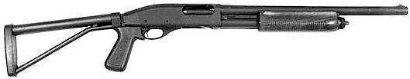
Remington Model 870
Ammo | Mag | Rng | ROF | Dam | Arm
12 Gauge | 7 | 35 / 40 | 4 | 4 | x4
Description: Originally developed in the early 1950’s the 870 has been a standard for police work since then. The 870 can have variety of attachments (almost as many as the Mossberg 500). It is very popular among civilians (there are a number of hunting and skeet versions) as well as law enforcement personnel.
Nation: United States Weight: 3.4 kg
Ammunition: 12 gauge Magazine: 7
Price: $550 Availability: ( C/S )

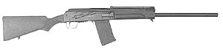
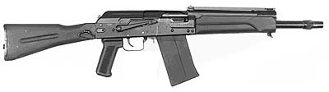
Saiga 12 / 12K
Ammo | Mag | Rng | ROF | Dam | Arm
12 Gauge  12 Gauge | 5 / 10  5 / 10 | 45  40 | 6  6 | 4  4 | x4  x4
Description: The Saiga is the Soviet combat shotgun. It follows after the AK and is full-auto. It is easy to work with and maintain. The 12 has a longer barrel than the 12K, but they are both equally as quick.
Nation: USSR Weight: 4 / 3.45 kg
Ammunition: 12 gauge Magazine: 5 / 10
Price: $900 / 1000 Availability: ( R/C )

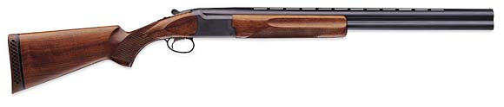
8 Gauge Over/Under
Ammo | Mag | Rng | ROF | Dam | Arm
8 gauge | 2I | 35 | 1 | 6 | x4
Description: The 8 Gauge is one of the most powerful firearms available. It does have a powerful kick and Referees should determine a limit on the Stature of the person using this weapon, or they may have a chance of being knocked off balance when using this weapon. 8 gauge is available in single and double barrels, black powder and cartridge. If a character uses the cartridge (or shelled) ammunition, it is suggested that they make or have made, reloadable rounds. You will not find them. The weapon is rare as well as the ammunition. If a character decides to use both barrels, it is my recommendation that they make a difficult Stature or Strength check or take 2-6 rounds recovering.
Nation: Varies Weight: 3 kg
Ammunition: 8 Gauge Magazine: 2I
Price: $800 Availability: ( -/- )

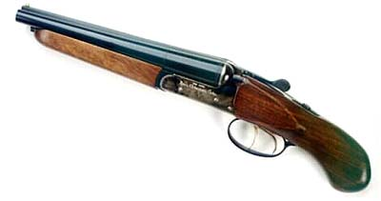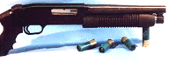
Sawed-off Shotgun
Ammo | Mag | Rng | ROF | Dam | Arm
20 Gauge  12 Gauge  10 Gauge | 2I  2I / 4  2I | 15  20  20 | 2  2 / 4  2 | 3  5  6 | x4  x4  x4
Description: At 16.5 inches the sawed-off shotgun is easy to hide away somewhere and gives a heck of a blast when it goes off. The short barrel increases the damage at close range (20 gauge is normally DAM: 2) but it’s range is halved. At medium range damage is half and long.. well there is no long range. Made for close combat only. Anything above 40 meters is not going to be affected. Pump shotguns like the Mossberg 500, etc can be cut down as well (known as “8-ball”). The Mafia used to use a 10 gauge pump shotgun for destroying property (as well as people).
Nation: United States Weight: 1.35 – 2 kg
Ammunition: Varies Magazine: 2
Price: Price of original weapon + 20% Availability: ( Varies )

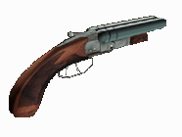
8 Gauge Sawed-off Shotgun
Ammo | Mag | Rng | ROF | Dam | Arm
8 Gauge | 1I / 2I | 15 | 1 | 7 | x4
Description: Referees must give heed if a character chooses to use this weapon. Ammunition will not be found; it must be made. It also makes a LOT of noise. People will know you are there. RCN increases one difficulty level to find a character using this weapon. Not to mention it is a true calling sign. Not many people have one of these and ‘survivors’ will remember characters by this weapon. Damage at Medium range is halved; anything past medium range is unaffected physically but must make a Coolness Under Fire check. The advantages of this weapon are obvious. Damage of 7, a very easy to conceal. When a character misses, the target character must make a CUF check at –3 for short range and –2 for medium range. Failure is treated like any other CUF failure (the character freezes or flees.)
Nation: Varies Weight: Varies kg
Ammunition: 8 Gauge Magazine: 2I
Price: Original value + 30% Availability: ( -/- )

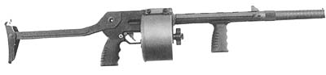
Street Sweeper
Ammo | Mag | Rng | ROF | Dam | Arm
12 Gauge | 30 / 50 | 35 / 40 | 8 | 4 | x4
Description: The Street Sweeper gained its popularity thanks to Hollywood. It is a fast firing weapon with a HIGH capacity magazine. Characters will most likely never find one, but if they search diligently they may come across it. It does have a collapsible stock and is balanced enough to fire short periods (1-2 combat rounds) with one hand.
Nation: United States Weight: 5 kg
Ammunition: 12 gauge Magazine: 30 / 50
Price: $1800 Availability: ( -/- )

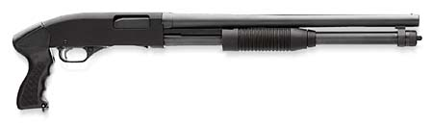
Winchester Defender
Ammo | Mag | Rng | ROF | Dam | Arm
12 Gauge | 8 | 35 / 40 | 4 | 4 | x4
Description: A pump shotgun designed specifically for police and home defense. If used without a stock the range is lessened to 35. A stainless steel version of this weapon has been issued to US Navy, Marines and Cost Guard. No high tech gismos to go array, and the stainless steel is protected against the salt water corrosion.
Nation: United States Weight: 2.5 kg
Ammunition: 12 gauge Magazine: 8
Price: $500 Availability: ( V/S )

